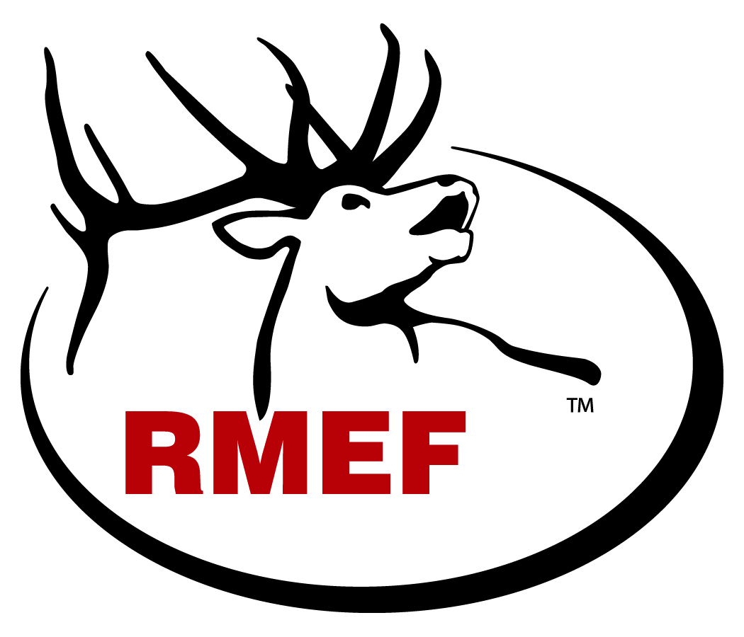
INSTRUCTIONS FOR COMPLETING

RMEF PAC PROPOSAL
Habitat Enhancement, Wildlife Management, Research

FORM # HEWMRE – 2016

All habitat enhancement and wildlife management project proposals must be submitted to the Rocky Mountain Elk Foundation (RMEF) using a current RMEF Project Proposal Form. Research project proposals may be submitted on a RMEF form or the format required by your agency or university. If you do not have the current form, please contact any of the individuals listed at the end of this document. RMEF requires a separate form for each project. The information requested on the proposal form assists with project evaluation, project tracking and communication by various means. Incomplete proposals could cause the PAC to rank the project lower than those with all the requested information available.

Project Title: Use a descriptive name that helps identify the area such as a locally recognized natural feature (i.e. mountain, creek, meadow, etc.). Subsequent projects in the same area may have the same name and can be designated by year or number, (Deer Creek Burn 2012 or Deer Creek Burn Yr. 2).

Project Synopsis: Briefly describe your project and what you hope to accomplish in one to five sentences. Please use popular writing style so that it can be used in RMEF’s BUGLE magazine or other media communication.

Location: List general project physical location. USFS should include Forest and District. BLM should include Field Office name. Game and Fish agencies should use Wildlife Management Areas or the equivalent. In the case of private land please list a general location, (two miles south of Lolo, MT).

County: List all counties where the treatment site is located. Please list the predominant county first.

Latitude and Longitude Map Location: Please provide the geographic center of the project treatment site. If the project consists of more than one treatment site (i.e. scattered weed spot treatments and water development), please select the largest treatment site and list its geographic center. This point should lie in the predominant county listed above. Please use decimal degree and carry it out six (6) or more decimal places so an accurate location can be recorded in RMEF’s GIS system.

Land Ownership: Please indicate land ownership pattern percentages on project treatment site.

Submitted By: Identify the project lead. This should be the individual most familiar with the project that can address project inquiries and is responsible for submitting a Project Completion Report. Include address, phone number and email.

Coordinated With: List state wildlife biologist or land management agency biologist (other than your own agency personnel) you consulted/communicated with when developing the proposal. Our expectation is that coordination with other agencies occurs prior to project submission. If you cannot get a signature on the original form, feel free to attach a note or email of support for the project.

Project Type: List the method of treatment. Examples: Prescribed burn, water development, mechanical thinning, road closure, seeding/planting, etc. If there is more than one project type, list each component on a separate line with its corresponding project costs.

Size of Treatment or Project Area: List actual acres treated. For prescribed burn, include the number of acres within the blackline perimeter. For road closures provide miles of road closed to motorized use. For noxious weeds estimate acres treated. If weed sites are scattered, please add up spot treatments to an acre equivalent.

Note: At the bottom right hand corner of the table is a field to fill in that asks what the total acres treated will be. We do not want to double count acres that are being treated with two or more treatment types at the same time with the same project and funds. If you burn an area and then spot treat for weeds, do not add them together but rather just show the burn perimeter as the total acres treated.

Project Work Schedule: List month and year when project field work is expected to be initiated and when field work is expected to be completed. RMEF realizes work priorities may change and delays may occur. Project funds are good for two years. You do not need to contact RMEF or resubmit if you are completing work within the two-year time period.

RMEF Funds: List amount of funds requested from RMEF. Break out request by project type in order for us to evaluate cost of each. Requests for multi-year funding should show annual amounts rather than total. RMEF policy limits funding to the first year of the project. Funding for subsequent years is contingent upon the project coordinator submitting a written progress report and a new project proposal form for the next year’s funding consideration. Projects demonstrating good progress receive priority for available funds.

Matching/Contributor Funds: Focus on project implementation costs. Do not include project planning costs. In the spirit of partnerships, RMEF requires at least a 1:1 match ratio but looks favorably on higher matching contributor funds. List all matching funds and their source. Example: USFS $2,000; BLM $1,500. Volunteer groups contributing labor should be identified as volunteer groups with a reasonable per hour rate. It is important to include all contributors as RMEF attempts to recognize them by various means.

Total Project Cost: Should include RMEF and all matching/partner funds.

Matching Funds Sources: Do not include RMEF funds in this section but rather list all contributors providing cash or in-kind services to the project. The total in this column should match the Matching/Contributor Funds in the section above.

Use of RMEF Funds:
RMEF contributes toward projects that extend an agency’s/organization’s ability to implement habitat enhancement, wildlife management or research projects. It is not our intent to replace agency/organization maintenance and operations budgets.

RMEF policy requires our grant funds be used exclusively for actual "on the ground" expenses incurred during project completion. RMEF policy strictly prohibits the use of our funds for administrative costs, overhead or indirect costs.

Routine agency/organization operations are not eligible for RMEF funding. Flight time for annual surveys is viewed as an agency responsibility. Flight time has been approved to test new sampling techniques or telemetry studies to determine habitat use, migration patterns, winter and summer range distributions.

Identify specifically how RMEF funds will be used (i.e. helicopter $5,000, seed $3,000, guzzler $2,500, etc.).

Salaries: Salaries for permanent employees will not be considered for RMEF funding. Salary costs of seasonal crews, biologist aides, and graduate student stipends may be requested for RMEF funding.

Equipment: RMEF does not fund capital facility or capital equipment items. Previously approved equipment purchases have been primarily limited to elk radio collars, telemetry receivers and antennas.

Planning, inventory and mapping: RMEF views these as agency responsibilities mandated by legislative or congressional action. Once the planning, inventory and mapping are completed, identified projects can be submitted for RMEF funding to implement the project. Since monitoring is so important to measure the success of the project, RMEF will consider requests for partial funding for formal project follow-up monitoring.

Elk Information: List the estimated number of elk that will benefit from the project. Do not include the entire herd unit population. List herd unit and hunt area if applicable along with elk population status.

Project Analysis: Clearly state the resource issues being addressed by the project and the possible factors contributing to the need for the project.

Project Objective: List specific objectives. Examples:
a) Improve water availability for elk in a high elevation meadow.
b) Increase forage production from XXX pounds per acre to XXX pounds per acre anticipated after treatment.
c) Improve habitat security or reduce elk vulnerability...
d) Protect migration corridor, winter range, etc.
e) Improve habitat on public lands to reduce depredation on private lands.

Project Strategies: List specific actions which will be taken to achieve the project objectives. Examples:
a) Deepen and seal existing dirt tank with bentonite to improve water holding capability.
b) Burn and reseed 500 acres of oakbrush winter range (list seed mixtures on worksheet).
c) Installed six gates/tank traps to close ten miles of road to motorized access, (obliteration, gate, reseed, etc.).
d) Radio collar 50 elk to determine distribution, habitat use and migration routes.

Area Description: Attach required map with project site clearly marked, discuss value or potential value of the area to the elk resource and elk use of the area.

Existing Project Area Land Management Activities: Is this project part of a larger project or series of projects? Identify related activities/programs that exist in support of the project. Include associated past RMEF project number and titles if tied in with this site. If there are many previous projects, mention the most recent project(s).

Project Monitoring Plan: Identify what monitoring techniques will be used to assess and quantify the effectiveness of the project as related to the objectives. What criteria will you use to evaluate the project’s success? Include both short term and long term monitoring. What monitoring feedback will you provide to RMEF? Established photopoints, especially those that show before and after photos are extremely valuable to show the results of the project and keep our membership excited about your conservation work.

Additional Project Benefits: Describe any additional benefits of the project from an ecological, educational and or socio/economic perspective. Examples:
- Benefits to other wildlife include any threatened or sensitive species.
- Benefits to other natural resources.
- Benefits to people and communities

Additional Comments: Any additional information you feel would be helpful in evaluation of the proposed project.

REPORTING PROCEDURE

The RMEF requires a Project Completion Report for all funded projects within 60 days of project completion. Photos are an essential part of the reporting process and are required as part of our grant. Photos are used extensively in RMEF presentations, videos, displays and publications. Crews and/or equipment in action, habitat scenic, pre- and post-treatment from the same vantage point, and wildlife using the project site are all good photo subject matter. RMEF will not be able to give photo credits for project photos since they are a requirement of the project funding and it is difficult to keep track of this information as the photos may be used by different RMEF departments for a variety of uses.

PROCEDURE FOR SUBMITTING PROPOSALS

Agency proposals should be submitted to the agency’s representative on the State Project Advisory Committee. Other applicants should submit proposals to the appropriate RMEF Regional Director. For additional information contact:

Eric Hull Christine Hastings
Conservation Program Specialist Project Information Manager
(406) 523-3444 (406) 523-4541
ehull@rmef.org christine@rmef.org

For U.S. Forest Service projects you may also contact:
Eric Tomasik
USFS/RMEF Liaison
(406) 329-3086
etomasik@fs.fed.us

For Bureau of Land Management projects you may also contact:
Linda Cardenas
BLM/RMEF Liaison
(406) 523-4580 W
lcardena@blm.gov

