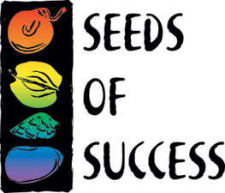
Seeds of Success Annual Report

Organization: (Agency, Field office/organization name) | Team Code:
Location:
Number of species collected: | Number of SOS collections made:
Collecting Season Summary (accomplishments and challenges):

Partners (Other agencies, NRCS, non-profit, etc.) and in what capacity you worked together:

Organizations that provided volunteers, and how many:

Education and Outreach: (include any work with other groups to promote or highlight Seeds of Success, i.e., citation for a newsletter, web article, conference/meeting display, or presentation on SOS and/or the Native Plant Materials Development Program, etc.)

Format  (talk, exhibit, publication) | Title | Name of Event or Publication | Location  (Nearest City, State) | Date

Distributions: (include information for collections that have been shipped out of your office to the Bend Seed Extractory or any other receiving institution)

Species | SOS Seed Coll. Ref. Num  (e.g., NV030-xx) | Receiving Institution  (e.g., Bend Seed Extractory) | What the SOS Material will be Used For  (e.g., restoration, research)

Internal Research using non-SOS collections: (include tracking information for collections that are kept at your office for Native Plant Materials Development projects. This section is for non-SOS collections only).

Species | Seed Coll. Ref. Num  (e.g., CBFO-23-2020) | What the non-SOS material will be used for

Please submit the final annual report to your Agency Coordinator December 15th.
BLM: Sarah Hill, sehill@blm.gov.
USFWS: Kelly Thomas, kelly_thomas@fws.gov.
NPS: Katie Vinzant, Katharine_Vinzant@nps.gov.

