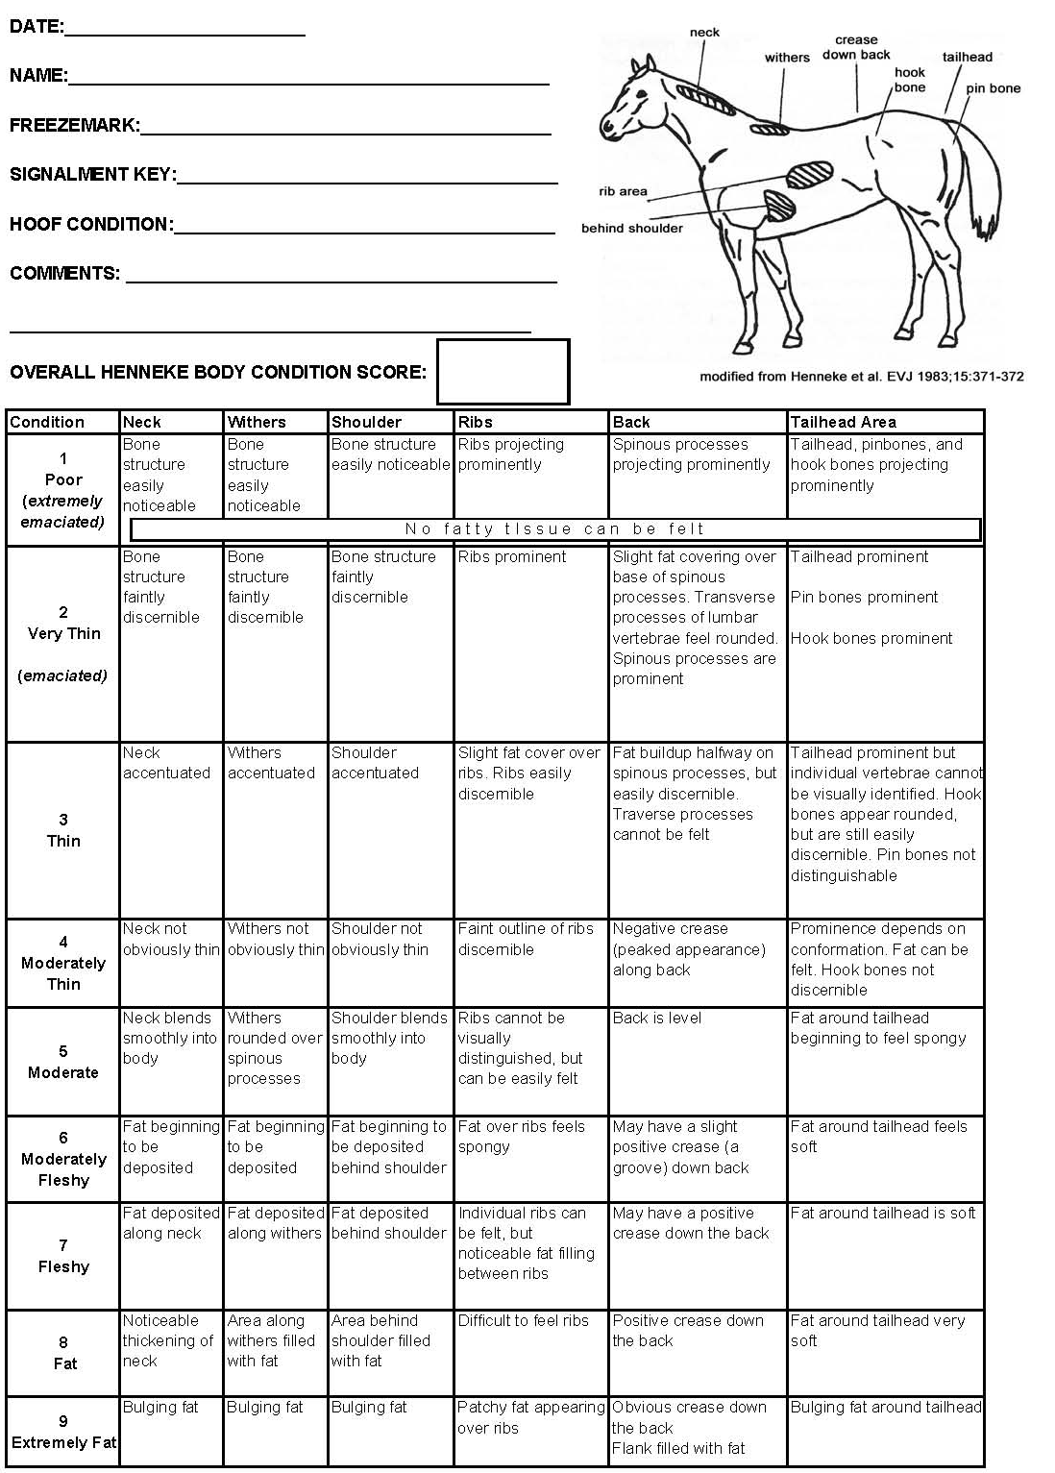
Attachment 3: Henneke Equine Body Scoring Chart

