Attachment 3

Form 4710-23
(March 2013)
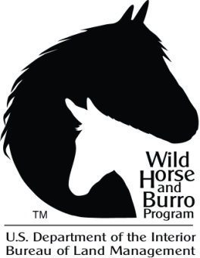
United States
Department of the Interior
Bureau of Land Management
Bill of Sale for Wild Horses and Burros

This is to certify that on this_________________ at ____________________________
(Date) (City)
USDI, Bureau of Land Management, _________________________________________
(Office or Facility Name)
Address ________________________________________________________________ (Address of BLM Office or Facility)

Sold the following (#): _________ wild horse(s) and/or (number) __________ burro(s).

To ____________________________________________________________________
(Name of Purchaser)

Of ____________________________________________________________________
(Purchaser’s Address)

Home Phone (Include area code) _____________________________
Alternative Phone (Include area code) _________________________
E-mail Address ___________________________________________

This document serves as both a sales contract and proof of ownership.

The BLM may seek criminal penalties against the purchaser if, in the course of this sale, the purchaser knowingly and willfully falsifies, conceals, or covers up a material fact; makes any materially false, fictitious, or fraudulent statement or representation; or otherwise violates 18 U.S.C. § 1001.

Purchaser agrees to provide humane care and to not maliciously or negligently injure the listed animals.

Purchaser agrees not to process any of the listed animals into commercial products. Purchaser agrees not to knowingly sell or transfer ownership of any listed animals to any person or organization whose intent is to process the animals or their remains into commercial products or whose intent is to resell, trade, or give away the animals or their remains for processing into commercial products.

If the purchaser makes any material misrepresentations in the applicable “Application to Purchase Wild Horses and Burros,” “Bill of Sale,” or during any negotiations with the BLM leading up to purchase, including, without limitations, representations about the purposes and/or use for which the animals are obtained, then the sale is voidable at the discretion of the BLM.

Purchased wild horses and/or burros cannot be returned to the public lands unless the BLM has issued a permit or otherwise authorized the purchaser to do so, such as through a livestock grazing or recreational permit.

Purchaser understands the listed animals are wild and ungentle, and due to their age and temperament may never become accustomed to human contact or be trainable for handling like domestic livestock.

Purchaser agrees to provide adequate facilities to contain and care for these animals.

Purchaser acknowledges that the seller makes no express or implied warranties as to the merchantability or fitness for any particular purpose for any wild horses or burros purchased under this program.

Upon sale, the listed animals are no longer considered wild free-roaming wild horses or burros. Sale of animals is final upon pick-up, which is the responsibility of the purchaser.

Purchaser has read the above statements, and understands and agrees to these terms.

_________________________________ __________________________________
Authorized Officer Signature of Purchaser

_________________________________ ___________________________________
(Date) (Date)

Form of Payment: _____________________________

# | Freeze mark | Signalment Key | Price
1
2
3
4

